# How to upload NFT metadata to IPFS for free

## IPFS is natively integrated into Tatum and completely free to use. Learn how to store your NFT metadata in a few clicks.



[Antonis Kazoulis](https://medium.com/@antonis.kazoulis?source=post_page-----15d591262fb-----------------------------------)

[Follow](https://medium.com/m/signin?actionUrl=https%3A%2F%2Fmedium.com%2F_%2Fsubscribe%2Fuser%2Fc8f0caf3c521%2F15d591262fb&operation=register&redirect=https%3A%2F%2Fblog.tatum.io%2Fhow-to-upload-nft-metadata-to-ipfs-for-free-15d591262fb&user=Antonis+Kazoulis&userId=c8f0caf3c521&source=post_page-c8f0caf3c521----15d591262fb---------------------follow_byline--------------)

[Nov 22, 2021](https://blog.tatum.io/how-to-upload-nft-metadata-to-ipfs-for-free-15d591262fb?source=post_page-----15d591262fb-----------------------------------) · 3 min read

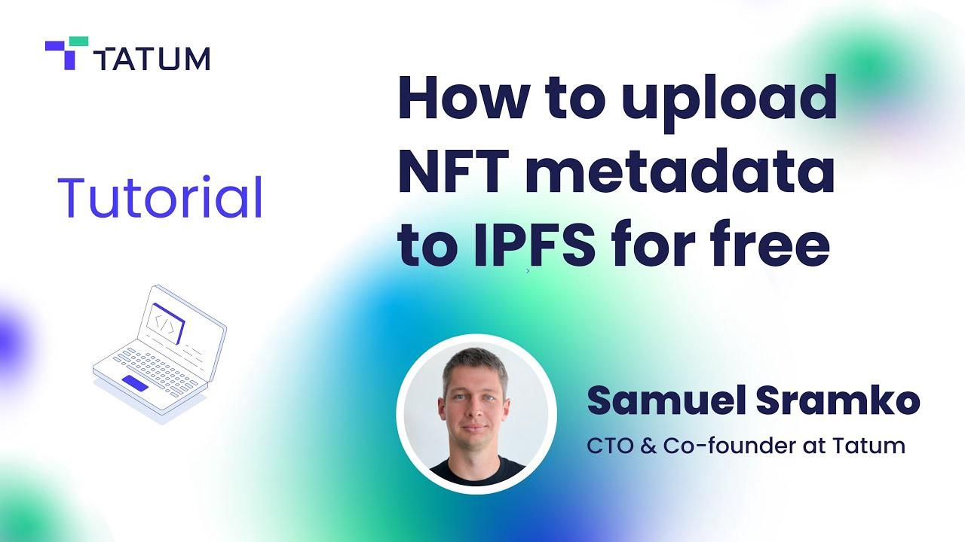

If you’re creating NFTs, you’ll need to store your NFT metadata (pictures, videos, audio files) in a secure, distributed database so it will always be connected to your NFTs. Metadata is what gives an NFT its unique value and is essentially what the NFT represents.

Following our [video tutorial](https://www.youtube.com/watch?v=0hD9O-2nWx8) on how to upload NFT metadata to [IPFS](https://ipfs.io/), we’ll show you how to do everything, step by step, in this guide. Follow these simple steps to easily store your NFT metadata on IPFS for free, for files up to 50 MB.

## What is IPFS?

The InterPlanetary File System is a protocol and P2P network for storing and sharing data. Once data has been uploaded to IPFS, it cannot be altered and will live on in the decentralized storage database forever. For this reason, it’s an ideal place to store your NFT metadata.

# Step 1: Store data

What’s important to note is that there are a couple of steps and a sequence of actions for storing your metadata. First, you upload the data on IPFS, then create a JSON scheme that references the uploaded file, then upload the JSON scheme to IPFS, and then include the IPFS hash of the JSON scheme in the NFT when you mint it.

Put simply, the NFT points to the metadata JSON, and metadata JSON points to the content you are actually attaching to the NFT.

Firstly, use the following [API call](https://tatum.io/apidoc.php#operation/StoreIPFS) to upload your metadata to IPFS:

What you need to do next is use the link/hash generated by the request and create a metadata JSON file that references it.

# Step 2: Create a JSON metadata scheme

A JSON [metadata scheme](https://gateway.pinata.cloud/ipfs/bafybeidi7xixphrxar6humruz4mn6ul7nzmres7j4triakpfabiezll4ti/metadata.json) usually includes name, description, and image fields and looks like this:

The name should be the name of your NFT, the description should be a brief explanation of what the content is about, and the image will be the IPFS hash generated from the previous step. Don’t let the name “image” confuse you. This is the place you would upload the metadata hash for a video, image, audio file, or whatever else you want to include in your NFT.

Additionally, it would be good to preface the hash with “ipfs://” for future reference. You can then save the JSON file.

# Step 3: Upload your saved JSON metadata scheme to IPFS

Using the same API call as step 1, you will then upload the saved JSON file and that will, in turn, generate another IPFS hash. This new hash is the one you can include in the “URL” field of the [mint NFT API call](https://tatum.io/apidoc.php#operation/NftMintErc721) when you want to mint a new NFT.

For a more detailed breakdown of the process, you can always refer to the dedicated [guide](https://docs.tatum.io/guides/blockchain/how-to-store-metadata-to-ipfs-and-include-it-in-an-nft) in our [how-to content library](https://docs.tatum.io/guides/blockchain).

# That’s a wrap!

You’ve just learned how to upload your NFT metadata on IPFS in a few simple steps.

If you want to dive deeper into what you can do using Tatum, we’d recommend checking out our:

* [YouTube workshops](https://www.youtube.com/channel/UCF-OAfXNJ9h3U2ycHE1NGNw)
* [Documentation](http://docs.tatum.io/)
* [Full API documentation](https://tatum.io/apidoc)
* [Blog](http://blog.tatum.io/)

Don’t forget to follow us on our [Linkedin](https://www.linkedin.com/company/tatumio/) and [Twitter](https://twitter.com/tatum_io) to keep up with our news, and if you need any help along the way, please drop us a line on the Tatum [Discord](https://discord.gg/4TWtSP3vxU) or [subreddit](https://www.reddit.com/r/tatum_io/).

Happy coding!